Solving 2nd order ODE using

Laplace Transform Techniques

EXPERIMENT-4

CODE: -

clc

syms s t Y

a = input('Enter the coefficient of second deri of y:');

b = input('Enter the coefficient of first deri of y:');

c = input('Enter the coefficient of y:');

f = input('Enter the RHS function:');

d = input('enter the value of y(0)');

e = input('enter the value of Dy(0)');

F = laplace(f,t,s)

Y1 = s\*Y - d

Y2 = s\*Y1 - e

Sol = solve(a\*Y2 + b\*Y1 + c\*Y - F, Y)

sol = ilaplace(Sol,s,t)

fplot(sol)

INPUT 1: -

COMMAND WINDOW: -

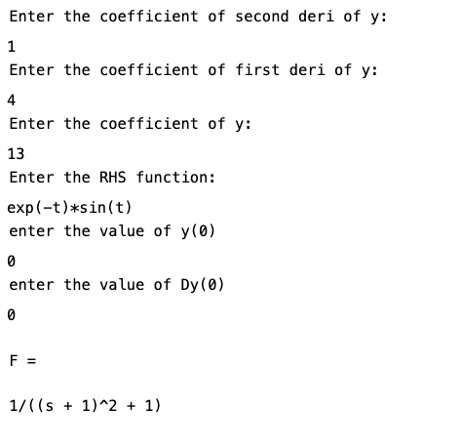

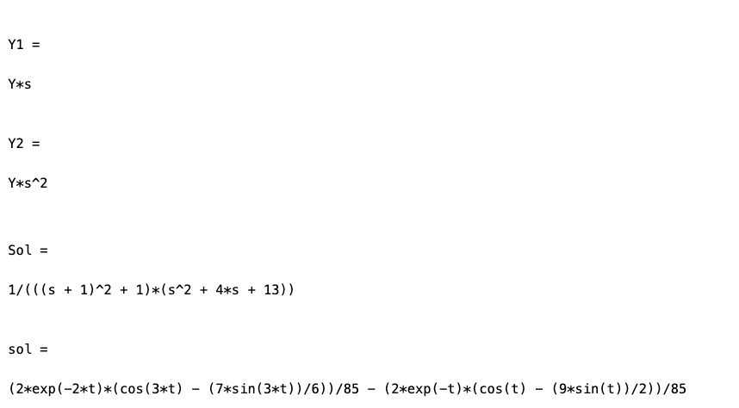

GRAPH: -

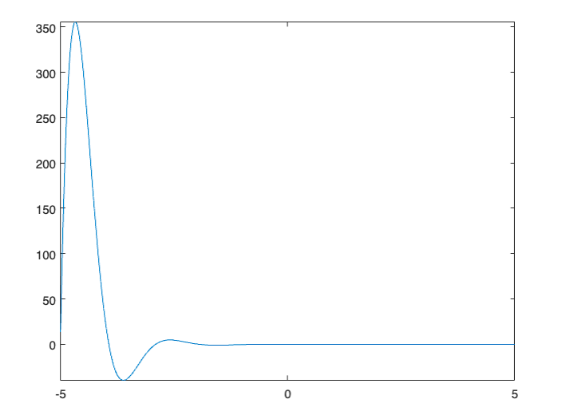

CODE FOR ODE USING LAPLACE WHEN STEP OR UNIT FUNCTION INPUT IS TAKEN:

clc

syms t s y(t) Y

a=input('enter the coefficient of second derivative of y:');

b=input('enter the coefficient of first derivative of y:');

c=input('enter the coefficient of y:');

f=input('enter the RHS function:');

d=input('enter the value of y(0) :');

e=input('enter the value of Dy(0) :');

de=a\*diff(str2sym('y(t)'),2)+b\*diff(str2sym('y(t)'),1)+c\*str2sym('y(t)')-f;

eq1=laplace(de);

eq2=subs(eq1,{laplace(y(t),t,s),y(0),subs(diff(y,1),t,0)},{Y,d,e});

eq3=collect(eq2,Y);

Y=solve(eq3,Y);

y=ilaplace(Y);

disp('The solution of the given DE is:')

disp(y)

ezplot(y)

INPUT 2: -

COMMAND WINDOW: -

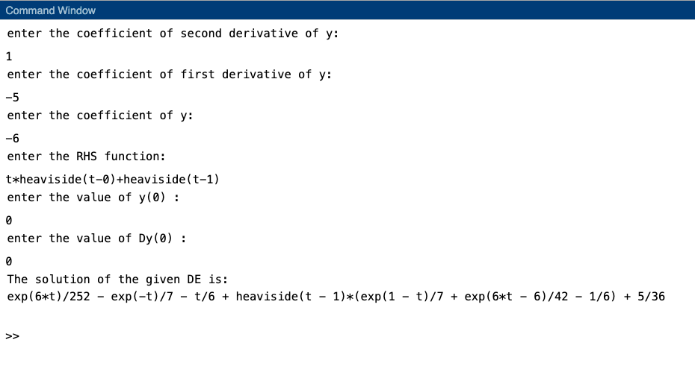

GRAPH: -

